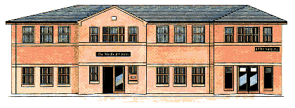
The Medical Centre 2 Frances Street
DONCASTER DN1 1JS
Telephone 01302 349431

11th September 2023 – 1pm

Frances Street Medical Centre Patient Participation Group Agenda:

1. Appointment Availability including extended access

2. Changes in the NHS and our Practice

3. Complaints and Compliments

4. Doncaster Healthwatch – Natalie

5. Your patient views on best practice (please put your thinking hats on for this discussion)
6. Any other business

Date of Next Meeting:
4th December 2023 – 6pm

