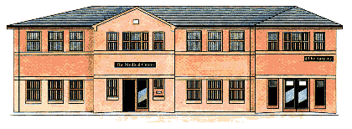
The Medical Centre 2 Frances Street
DONCASTER DN1 1JS
Telephone 01302 349431

PLEASE CONTACT THE PRACTICE TO CONFIRM ATTENDANCE.

17th June - 6pm
Frances Street Medical Centre Patient Participation Group Agenda:

1. Appointment Availability including extended access

2. Changes in the NHS and our Practice

3. Complaints and Compliments

4. Patient informatics/education

5. Your patient views on best practice (please put your thinking hats on for this discussion)

6. Any other business

Date of Next Meeting:
11th September – 1pm

