THE MEDICAL CENTRE
Like us on Facebook
@MedicalCentreDoncaster
Follow us on Twitter
@TMCFrancesSt
AUTUMN NEWSLETTER 2017
Staff News
In September we bid sad farewell to Dr Barbour who has been a devoted Doctor at The Medical Centre for 21 years and Dr Middleton has also retired, he has been dedicated 31 years to The Medical Centre they will be missed. We also bid farewell to Julie Utley one of the Practice Nurses here; we thank her for her support and dedication and wish her well in her new venture. We also say goodbye to Elaine Bassindale who has retired and we wish her well in her new chapter. We are delighted to introduce Dr Khan who joined us in August and we look forward to working with him. We also welcome Lisa Scott the new Advanced Nurse Practitioner, Anne-Marie Henson a Practice Nurse who will be joining our clinical team and Jane Hinds who is joining the Medical Support Team. Tracy Hudson, a member of the Medical Support team will be joining our clinical team as of October to train to become a Health Care Assistant; we wish her the best of luck.
We would like to thank our patients for their continued support during the last few difficult months and are look forward to the future with you all.

Flu Clinics 2017
The Surgery is now taking bookings for annual flu jabs. Flu vaccines will be available from the middle of September. We recommend all patients over 65 and anyone with a chronic disease e.g. Diabetes, COPD, Heart Disease, Asthma, have a flu jab. Please ring for an appointment or book on-line. If you have an appointment at the surgery and we have the flu vaccinations available you can have this during your appointment. Please ask at reception if you are unsure.

Go Sober for October
Go Sober for October and be a superhero! Go Sober encourages people to go booze-free for the 31 days of October and raise funds for Macmillan Cancer Support. You can sign up and find loads of fundraising ideas for your month without drinking.

Wear It Pink!
On Friday the 20th October we will be holding a day where all of staff at The Medical Centre will be wearing pink to raise money and make life-saving research happen. Breast cancer is still here. It’s still tearing apart the lives of families and it’s still taking the lives of the women we love on a heart breaking scale.

Stoptober
Stoptober is back for 2017! This is a national campaign to help people to stop them quit smoking. No matter how long you've smoked for, quitting can help improve your health straightaway. More than 1 million people have used Stoptober to help them quit. All the support you need to quit from a free app and daily emails, to face-to-face expert support and much more –
they have got loads of support to help you quit, so choose the combination that's right for you.

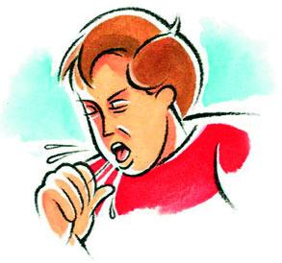
Cough & Cold Advice During Autumn
There is no cure for the common cold and antibiotics have no effect on viruses, but you can treat the symptoms with some practical self-help measures and over the counter medicines. Your local Pharmacist has been trained to advise you on what is best for you. “Catch it and bin it”. Wash hands regularly with soap and water and keep surfaces clean.

Macmillan Coffee Morning
The Medical Centre held a Macmillan Coffee Morning on Thursday the 28th September which was a great success raising £100. We would like to thank patients that attended and offered donations of both cakes and money. Tracy, a member of the Medical Support team won guessing the height of the cake and generously donated her wwinnings into the donations box. The Office Manager Niki won the Best Baker status along with a badge.

Patient Participation Group
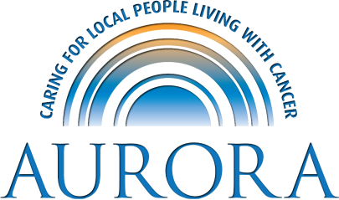
On 28th September 2017 we had a Therapist and two volunteers attend our 6 weekly patient participation group they spoke about the charity and the different support groups they offer and what they offer along with the spa services do. We also had a member of the Alzheimer’s Society attend who discussed their services which include the Memory Café and Admiral Nurses and the statistics surrounding Alzheimers in the Doncaster area. For more information speak to a member of the Medical Support Team for a copy of the minutes.

Staff Training Dates
The Medical Centre is closed for staff training from 12.00 pm on the following dates:
- Wed 18th October 2017
- Wed 22nd November 2017
- Wed 29th November 2017

Please remember to collect prescriptions before 12pm.

DNA Policy:
When a patient fails to attend an appointment a note is made in their medical record. If a patient fails to attend 2 appointments within 12 months, the patient will receive a letter reminding them of the importance of cancelling unwanted appointments in good time and detailing the consequence of not doing so.
If the patient fails to attend 3 appointment in 12 months, the Practice Manager will write to the patient informing them this will be brought to the attention of the Partners where the usual course would be to remove the patient from our list without further discussion unless the patient is able to provide a valid explanation in support of them remaining on the list.
If you do need to cancel an appointment please give at least 24 hours’ notice.
In the last 3 months we have had a total of 534 appointments not attended.
- July – 193
- August– 164
- September - 177
Repeated DNA (did not attend) offenders may be removed from the Practice list.
To cancel appointments please call:
01302 349431

