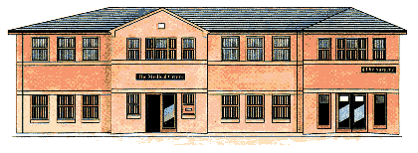
The Medical Centre 2 Frances Street
DONCASTER DN1 1JS
Telephone 01302 349431
Information Sheet
Appointment Availability – No changes
- We give over 850 appointments per week (Our contract only asks us to provide 500 per week)
- We have access to the Health Bus with a GP on board
- You can go to a Pharmacy/we can book you in to see a pharmacist in your local chemist
- We have an in-house physio based at the Practice Tuesdays with 20 appointments a week
- We have access to book you into appointments at Cavendish Court and Albion Place
- From October we will have access to book additional evening and Saturday appointments at Lakeside, Scott Practice and Oakwood Surgery
Changes in the NHS and Our Practice
- Appointment pre-booking
Complaints and Compliments
- Attached Family and Friends results
Patient Informatics/Education
- Follow up from last meeting
Best Practice
- A discussion around what we do best
Any other business
- What do you want to talk about?

Date of next meeting: 11th September 1pm

