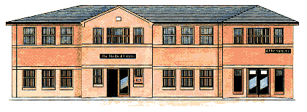
The Medical Centre 2 Frances Street
DONCASTER DN1 1JS
Telephone 01302 349431

PLEASE CONTACT THE PRACTICE TO CONFIRM ATTENDANCE.

22nd May - 1pm
Frances Street Medical Centre Patient Participation Group Agenda:

1.Appointment Availability including extended access

2. Changes in the NHS and our Practice

3. Complaints and Compliments

6. Patient informatics/education with special speaker from Health Watch

7. Any other business

Date of Next Meeting:
17th July – 6pm

