Spring Newsletter 2018
Like us on Facebook
@MedicalCentreDoncaster
Follow us on Twitter
@TMCFrancesSt
Staff News
We are delighted to introduce Dr Khan who joined us as a GP partner in April. We would also like to welcome Matthew and Beth who have joined The Medical Centre as part of the Medical Support Team. There have been two births at the surgery starting with Nichola who had a baby boy on Friday 23rd February and Amy who has also had a little boy on Friday 2nd March. We send them our congratulations and well wishes.

Appointments at The Medical Centre
You may have noticed that the appointments system has changed at The Medical Centre to primarily book on the day appointments, there are still appointments to book in advance for reviews and non-urgent ailments. This is due to the high numbers and non-attended appointments we have been experiencing which then prevents the appointment being used for another patient.

A Message from the Partners
As of the 1st April 2018 Dr Marney Khan joined Mr Christopher Simmons in partnership at The Medical Centre. This new partnership consolidates your practice and enables it to face a bright future. The Partners are committed to provide you with a first class medical service that continues to meet your needs and will look to develop its clinical expertise in going forward. This practice has over 100 years’ experience of providing care to you and your family and takes great pride in working you with to improve your health and wellbeing. You will see when you enter the building that we are in the process of totally refurbishing your centre to high standard and hope you will enjoy using our improved facilities, this work is due to be completed in August this year and by then all clinical rooms will have been refitted and all patient areas redecorated and refurbished. The staff at The Medical Centre are committed to giving you the best service possible and look forward to seeing you in our updated and refurbished premises soon (though not too soon as we want you to keep well!).
The NHS Turns 70
This year the NHS turns 70 on the 5th July and we would like to celebrate the amazing achievements that has been accomplished by the NHS throughout the years. We will be displaying a timeline of the success within the NHS through the ages; on July 5th we will also be holding birthday celebrations. On the run up to this we would like our patients to share anonymously how the NHS has helped them. This information will be shared with others in the practice as a way of celebrating the work provided by the NHS.
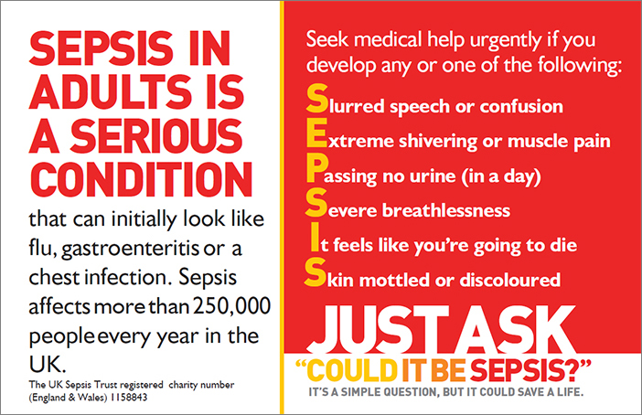
Summer Is Here!
If you’re jetting off on your holiday to enjoy the sunshine we have a few tips for keeping healthy this summer:

Immunisations – if injections are required for your holiday destination, please book an appointment with a nurse as soon as possible prior to your travel date.
Sunburn – Remember to take shade at regular intervals, and wear a hat to prevent sunstroke. If you do get burnt have a cool shower or bath and apply a good quality after-sun, if you are seriously burnt seek medical attention.
Dehydration – Make sure you drink plenty of water, fruit juices or ice pops.

Carers
A carer is anyone who cares, unpaid, for a friend or family member who due to illness, disability, a mental health problem or an addiction that cannot cope without their support. We are always looking at updating our carers register and if this applies to you please inform the surgery, this allows us to support and refer you for support while you support others. In Doncaster there are around 33,200 adult carers and 1,000 young carers identified in Doncaster. There are services in Doncaster to support carers, for more information ask one of the Medical Support members.

3 Before GP
We are asking our patients to adopt a new three-step mantra to help relieve pressures on GP services. This mantra has been published by the Royal College of GPs to help combat the pressures within general practice.
Ask yourself these three questions before booking an appointment with their GP
CAN I?
- Self-care
- Use NHS Choices or similar reputable websites/ resources
- Seek advice/treatment from a pharmacist?

Home Visits
We offer home visits for housebound patients and we ask that if you require a home visit to request this before 12 noon unless it is an emergency. With a visit request we have the Doctor call you back to discuss the symptoms from this a visit may be arranged either with the GP or with other community services as required.
Care Navigation
There are some ailments, illnesses and conditions that can be treated outside of the practice. These include;

- Back-ache, sprains and strains
- Colds
- Conjunctivitis
- Constipation
- Coughs
- Diarrhoea
- Earache
- Haemorrhoids
- Hay fever
- Head lice
- Headache and fever
- Heartburn and indigestion
- Insect bites and stings
- Mild eczema and dermatitis
- Minor fungal skin infections
- Mouth ulcers
- Nappy rash
- Sore throat
- Teething
- Threadworm
- • Thrush
These ailments can be treated at a chemist as part of the Minor Ailments Scheme and is free if you do not pay for your prescriptions.
If you need help with regards to;
•Feeling Low / Down
•Feeling depressed
•Feeling Anxious / worried
•Dealing with Phobias
•Feeling stressed
•Problems with worry or anxiety
•Panic Attacks
•Poor sleep
You can contact The Talking Shop on 01302 565556 to discuss your problems and arrange an appointment, this is also a walk in service.

Your Patient Participation Group Needs You!
The Medical Centre holds a 6 weekly Patient Participation Group in the practice for patients to become involved within aspects of the services delivered and keeping up to date about any changes that are happening. This meeting also allows us to share ideas and hold discussions on the latest updates to NHS services. Our next Patient Participation Group is on Thursday 21st June starting at 1:30pm in the upstairs waiting room. If you would like to be a part of the Patient Participation Group but are unable to attend these dates and times you can join are virtual group. You can do this by just giving your email address to the person on reception and you will be added to the group.

DNA Policy:
When a patient fails to attend an appointment a note is made in their medical record. If a patient fails to attend 2 appointments within 12 months, the patient will receive a letter reminding them of the importance of cancelling unwanted appointments in good time and detailing the consequence of not doing so.
If the patient fails to attend 3 appointment in 12 months, the Practice Manager will write to the patient informing them this will be brought to the attention of the Partners where the usual course would be to remove the patient from our list without further discussion unless the patient is able to provide a valid explanation in support of them remaining on the list.
If you do need to cancel an appointment please give at least 24 hours’ notice.
In the last 5 months we have had a total of 1011 appointments not attended.
- December - 161
- January – 213
- February– 214
- March - 221
- April - 202
To cancel appointments please call:
01302 349431
825

