C:\Users\GPuser\Pictures\follow+us+on+twitter.png

**Autumn Newsletter 2015**

*@TMCFrancesSt*

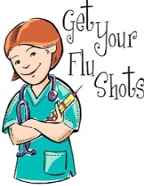**Welcome to our Autumn Newsletter**

**Flu Clinics 2015**

The Surgery is now taking bookings for annual flu jabs. Flu vaccines will be available from the end of September. We recommend all patients over 65 anyone with a chronic disease e.g. diabetes, COPD, heart disease have a flu jab and. Asthmatics are also entitled if a steroid inhaler forms part of their treatment plan. Please ring for an appointment or book on-line. If you have an appointment at the surgery during late September or October you can have your flu jab whilst in the surgery - please remind us before you leave! Please ask at reception if you are unsure.

**The practice is holding Flu Clinics on the following dates:**

* Sat 26th Sep - 8am till 12pm
* Sat 10th Oct – 8am till 12pm
* Sat 24th Oct – 8am till 12pm



**Vaccinations**

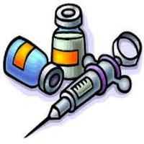Pneumococcal vaccinations are also recommended for the patients; listed in the above paragraph and will help prevent against the most common strains of pneumonia. A single vaccine will last a lifetime so patients only ever require one. Please ring on 01302 349431 to book your appointment with George or in the Treatment Room.

Shingles vaccines are now available for most patients between the ages of 70 and 80. The NHS has adopted a rolling program and the target group this year is: Any patient who was 78 or 79 on 1st September 2015 (until they reach age 80) or any patient who was 70, 71 or 72 on 1st September 2015 and hasn't already had the vaccine. The vaccines have been found to reduce the chance of getting shingles and also reduce the severity of the condition. As it is a live vaccine some patients may not be able to receive this vaccine (e.g. if immunocompromoised). Ring the surgery to check. Please note the shingles vaccine cannot be given at the same time as the flu or pneumococcal vaccine.



o-SMOKING-facebook **Stoptober’s back!**

Join the thousands quitting smoking and going sober for 28 days this October. Stoptober is the 28-day national stop smoking challenge and going sober.

Research has shown that people who manage to stop smoking for 28 days are five times more likely to stop for good. GIVE IT A GO!



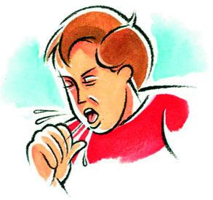**Cough & Cold advice during autumn**

**T**here is no cure for the common cold and antibiotics have no effect on viruses, but you can treat the symptoms with some practical self-help measures and over the counter medicines. Your local Pharmacist has been trained to advise you on what is best for you. “Catch it and bin it”. Wash hands regularly with soap and water and keep surfaces clean.



**Whooping Cough**

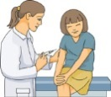**Whooping Cough Vaccinations are offered to Pregnant Patients who are 28 - 38 weeks pregnant.**

Those Pregnant patients, who are within this stage of pregnancy, please ask a receptionist to book you in for an appointment.



**Free NHS Health Checks**

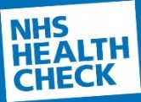NHS Health Checks are being offered to people aged between 40 and 74 once every five years who have no noted long term conditions.

The check is to assess your risk of developing diabetes, heart disease, kidney disease, stroke and dementia. If there are any warning signs, then together we can do something about it.

Eligible patients will receive an invitation to book an appointment.



**DNA (did not attend)**

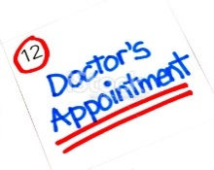In the last 3 months we have had a total of 609 DNA (did not attend) appointments which are shown below:

June – 221

July – 202

August – 197

**Repeated DNA (did not attend) offenders may be removed from the Practice list.**

To cancel an appointment pleases call:

**01302 349431**



**Cancellation of appointments**

Over the last few months, there has been a considerable increase in the number of appointments being cancelled at short notice which we are then unable to offer to other patients.

**Please make every effort to attend to all appointments made.**

If you do need to cancel an appointment please give at least 24 hours’ notice. Please also remember that if you cancel an appointment it may not be possible to offer you an alternative appointment on the same day.



**Staff training dates**

The Medical Centre is closed for staff training from 12.00 pm on the following dates:

* **Wed 23rd Sep 2015**
* **Wed 30th Sep 2015**

Please remember to collect prescriptions before 12pm.

**To access a doctor in an emergency please telephone:**

**01302 349431**



**Choose Well**

There are many different ‘Choose well’ ways that you can help yourself get the right kind of care:

* **Self-care** – look after yourself at home with a well-stocked medicine cabinet
* **Pharmacist** – for expert advice on common illnesses and the best medicines to treat them
* **GP (doctor)** – for illnesses that just won’t go away, arrange to see your doctor
* **A&E or 999** – only if you need very urgent medical attention

**Always pick the care you need**



**Your Patient Participation Group needs you**

Our next patient participation group will be on 15th October 2015 at 1.30pm. Members of Falls Clinic Team will be coming in to discuss services they provide.

The rest of the dates for the patient participation group are available online and The Medical Centre.