The Medical Centre – Frances Street - Newsletter

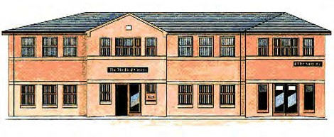
The Medical Centre Summer 2020 Newsletter will update you on the latest Coronavirus changes and how the practice is running to prevent the spread of Coronavirus and an update on the Patient Participation Group.

Coronavirus Update

On July the 4th 2020 we will be seeing a further easing of lockdown. It is still important to stay alert, socially distance and wash our hands to help to prevent the spread of the virus. Here are a few things that you can start to do from 4th of July:
- Meet in groups of up to 2 households, private or publically, indoors or outdoors – you must distance from those not living in your household.
- Restaurants, pubs, cinemas, visitor attractions, hotels and campsites will open
- Libraries, community centres, places of worship, outdoor playgrounds and outdoor gyms will open
- Stay overnight away from your home with your own household or support bubble or with members of one other household
- Patient Participation Group
- The PPG is a great way to understand more about what goes on in your practice and having your say on how the practice runs. We do a number of interactive sessions a year where you can understand a little more about the services that Doncaster offers our patients.
- For the safety of our patients and staff during the current pandemic we have had to postpone any group meetings. However we look forward to inviting you back to our sessions when it is safe to do so.
- The group is open to all patients; please contact reception if you are interested in joining. The meetings are Thursday afternoons every 6 weeks,

