THE MEDICAL CENTRE
SUMMER NEWSLETTER 2017

It is with profound sadness that we inform you of the peaceful passing of Dr Braidwood on the 21st June. It is a tragic loss to the practice and he will be deeply missed, we appreciate your patience and understanding during this difficult time

Staff News
We bid farewell to Amanda Thompson, an Advanced Nurse Practitioner at the surgery and we thank her for all her hard work and dedication.

Summer Is Here!
If you’re jetting off on your holiday to enjoy the sunshine we have a few tips for keeping healthy this summer:

Immunisations – if injections are required for your holiday destination, please book an appointment with a nurse as soon as possible prior to your travel date.
Sunburn – Remember to take shade at regular intervals, and wear a hat to prevent sunstroke. If you do get burnt have a cool shower or bath and apply a good quality after-sun, if you are seriously burnt seek medical attention.
Dehydration – Make sure you drink plenty of water, fruit juices or ice pops.
Bites and stings – it is not easy to avoid hungry insects in the summer heat but if you do get bitten or stung, try to remove the sting if still left inside you with fingers or tweezers, wash the area with soap and water, put on a cold flannel and raise the area to avoid swelling, use an antihistamine cream or spray – avoid itching as this can cause infection.

Minor Ailments Scheme Available at your local pharmacy:
The NHS Minor Ailment Scheme is for adults and children from the age of two who want treatment for a minor illness included in your local scheme.
You are able to use the NHS Minor Ailment Scheme to get advice and, when appropriate, treatment for certain common illnesses without seeing a GP.
If you do not pay for your prescriptions, medication is issued free of charge.
This scheme is convenient as there is no need to make an appointment at the surgery and many pharmacies are open at the weekend. Pharmacists can also refer you to see someone at the surgery if necessary.

Blood Glucose Meters For Diabetics
Diabetics will be informed at their diabetes review appointment as to whether they need blood glucose testing machines and equipment. The surgery can provide meters for those who need them free of charge. Currently we are only able to supply the following 2 meters: Accucheck performa nano and Omnitest. We will not be able to prescribe strips and lancets if patients buy alternative meters from now on. We will continue to prescribe for patients who already have an alternative type of meter.

Staff Training Dates
The Medical Centre is closed for staff training from 12.00 pm on the following dates:
- Wed 12th July 2017
- Wed 20th September 2017
- Wed 27th September 2017

Please remember to collect prescriptions before 12pm.

Prescriptions
You can order your prescriptions seven days before they are due. This can be done through either our prescription line, 01302 811188, or online (please speak to reception if you would like to set this up). If you are aware that your medication review is due please arrange the necessary appointments as not doing this could put a delay on issuing your medication.
Accident and Emergency
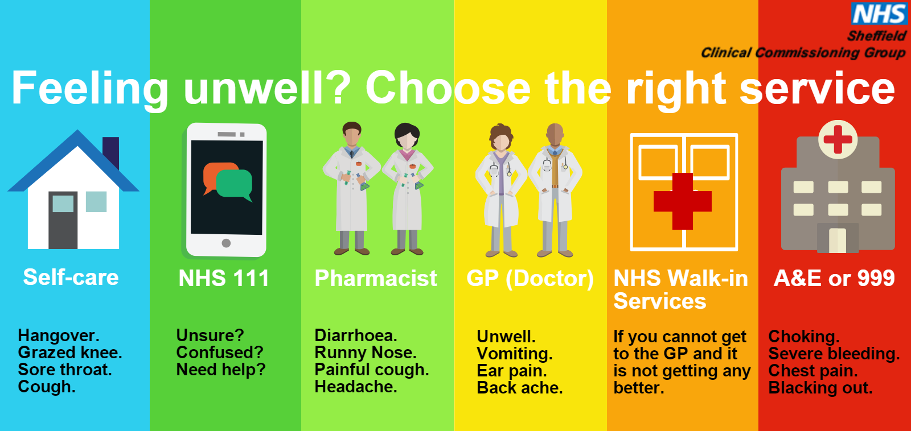
The Accident and Emergency department is for emergency situations only. Please see the helpful guide below if you are unsure of where to go.
If you require medical assistance whilst the practice is closed you can contact the Doncaster Same Day Health Centre on 0300 123 3103 or if you dial the number for The Medical Centre you will be put through to the emergency Out Of Hours service. This is an emergency out of hour’s service. THIS IS NOT A SERVICE TO ORDER PRESCRIPTIONS.

DNA Policy:
When a patient fails to attend an appointment with a healthcare professional a note of the date and time is made in their electronic medical record. If a patient fails to attend 2 appointments with a healthcare professional within a 12 month period, the patient will then receive a letter reminding them of the importance of cancelling an unwanted appointment in good time and detailing the consequence of not cancelling.
If, following this, the patient fails to attend another appointment (3 appointment in 12 months), the Practice Manager will write to the patient informing them this will be brought to the attention of the Partners who will decide the next course of action. The usual course would be to remove the patient from our list without further discussion unless the patient is able to provide a valid explanation in support of them remaining on the list.
If you do need to cancel an appointment please give at least 24 hours’ notice. Please also remember that if you cancel an appointment it may not be possible to offer you an alternative appointment on the same day.
In the last 3 months we have had a total of 573 (did not attend) appointments which are shown below:
- June – 174
- May– 211
- April – 188
Repeated DNA (did not attend) offenders may be removed from the Practice list.
To cancel appointments please call:
01302 349431
Minor Ailments Scheme
Available at your local pharmacy:

The NHS Minor Ailment Scheme offers advice and treatment for certain common illnesses without seeing a GP.
Ailments included in this scheme are;

• Back-ache, sprains and strains
• Colds
• Conjunctivitis
• Constipation
• Coughs
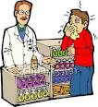
• Diarrhoea
• Earache
• Haemorrhoids
• Hay fever
• Head lice
• Headache and fever
• Heartburn and indigestion
• Insect bites and stings
• Mild eczema and dermatitis
• Minor fungal skin infections
• Mouth ulcers
• Nappy rash
• Sore throat
• Teething
• Threadworm
• Thrush

