The Medical Centre – Frances Street - Newsletter
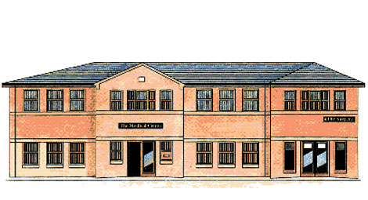
The Medical Centre Autumn 2020 Newsletter will update you on the latest Coronavirus changes and how the practice is running to prevent the spread of Coronavirus and an update on the Patient Participation Group.
Coronavirus Update
On the 14th of September the coronavirus national rules were changed to make them simpler for people to understand. You are now no longer able to meet in groups bigger than six people and ‘mingling’ is to be avoided. ‘Mingling’ meaning two groups of six getting together etc.
Schools have re-opened and all students are encouraged to return.
At the moment you’ll be aware that the number of cases of coronavirus are increasing and this is a worrying development as we head towards winter.
The government are introducing local lockdowns where needed but this does not include Doncaster at present, which is good news. It is doubly important that we keep social distancing, hand washing and face coverings when appropriate. We all need to do our bit to stop this dreadful virus spreading over the winter whilst we wait for a vaccine to be developed that will protect us.
Patient Participation Group
We are in the process of setting up a zoom meeting for any interested patients to attend virtually, we will be sending out SMS message when this is organised and also updating this newsletter so that as many patients as possible can attend.
Flu Clinics
We commenced our flu clinics on the 9th of September 2020, these are running all day every day until all eligible patients have had their flu vaccines. This is an appointment only system so please phone the practice to book your appointment and ensure you come on time but not early as access to the practice is still restricted. At present patients aged 50 – 65 who would not normally be eligible for flu vaccines but will be this year cannot book until further notice as we are currently prioritising at risk groups.

