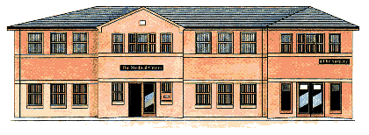
The Medical Centre 2 Frances Street
DONCASTER DN1 1JS
Telephone 01302 349431

CHANGE OF VENUE:
Please be aware, we have changed the meeting venue to take place at DONCASTER LIBRARY – FLYING SCOTSMAN ROOM, 2ND FLOOR.

12TH February 2024 – 1pm

Frances Street Medical Centre Patient Participation Group Agenda:

1. Appointment Availability including extended access – chest clinic

2. Changes in the NHS and our Practice

3. Complaints and Compliments

4. Pharmacy First

5. Any other business

Date of Next Meeting:
22nd April – 6pm - The Medical Centre in the Practice

